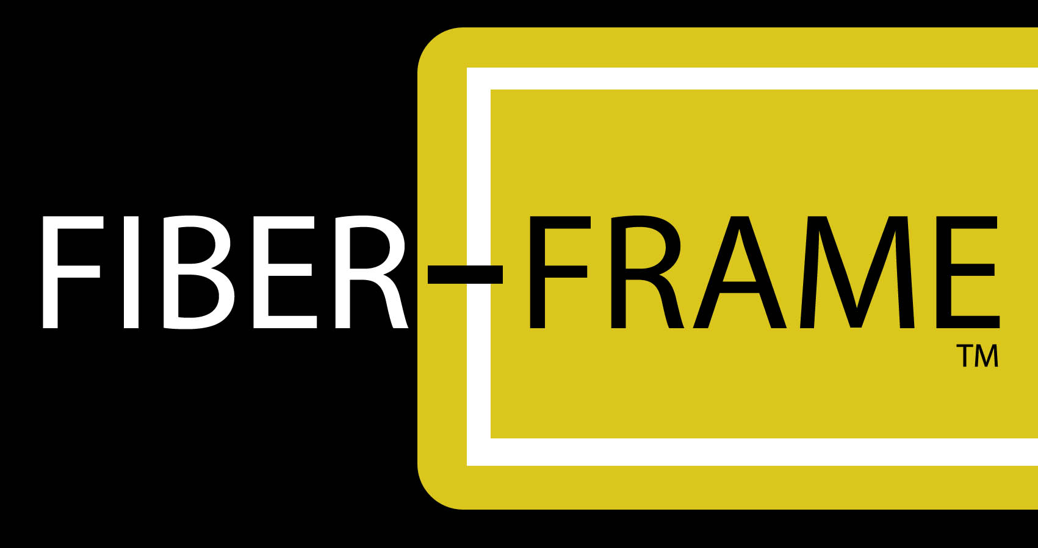

Parts List and Installation Instructions

Parts Included:

(2) Fiberglass uprights (2) Fiberglass crossmembers
(2) Steel ground rods, 1” x 40” (4) 5/16” x 2.5” socket cap screws (with hex key)

Note: Although the fiberglass is cleaned to remove fibers and dust, some people may still experience irritation, and the use of gloves at all times during installation is recommended.

Installation Procedure:

- Identify and mark potential Fiber-Frame install location(s).

- Contact your state, local or regional notification center (E.G., www.laonecall.com) to have all underground utilities marked in the area(s) identified as possible Fiber-Frame install location(s).

- Once utilities are marked and prospective location(s) cleared by notification center for ground intrusion to a depth of 30”, you may proceed with installation.

DO NOT INSTALL THE FRAME UNDER ANY CIRCUMSTANCES
PRIOR TO APPROVAL BY THE NOTIFICATION CENTER.

- Once the final frame location is approved, mark the ground rod entry points, as follows:

Frame width Distance apart
4’ 49.5”
5’ 61.5”
6’ 73.5”
8’ 97.5”
10’ 121.5”

- With the reflective end of the ground rods up, and with the drilled holes exactly facing each other, drive the ground rods into the ground at the ground rod entry points. The ground rods must be exactly plumb, and parallel to one another.

- Drive in the ground rods until the bottom of the reflective just reaches ground level. This represents the bottom of the uprights.

- Slide the uprights over the ground rods, with cable tie cleats facing inward.

- Using a bolt, align the lower upright holes with the ground rod holes. Remove bolt.

- Place the lower crossmember between the two uprights, with cable tie cleats facing inward. Insert bolts through the uprights and ground rods, engaging the threaded nuts located inside the ends of the crossmember. Do not tighten the bolts completely.

- Repeat this process with the upper crossmember.

- Tighten all four bolts snugly, but do not over-tighten. Fiber-Frame, LLC is not responsible for any damage caused by over-tightening of bolts.

- Your Fiber-Frame assembly is complete -- mount banners using black, UV resistant cable ties.

